Order of Worship
Messiah United Methodist Church
Sunday, September 20, 2026
Created For Connection – Connection Amongst Christians

Welcome, Announcements, Opening Prayer
Call To Worship

Pass It On (UMH #572)
The Way

Special Children’s Time
Prayer For Illumination

Scripture Lesson
Ephesians 4:1-6 (NIV)

Sermon
Prayers of the People
The Lord’s Prayer

Offertory
Amazing Grace
Doxology
Offering Prayer

Big House

Benediction

Looking to make an online offering?
Scan this QR code

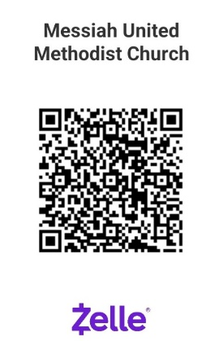

PayPal

THIS WEEK – September 20, 2026 – All-In Worship
Greeters – Kumjian family
Ushers –Deb Graham & Annette Kellum & kids
Offering Counters – Phyllis Abeshaheen, Pat Wright
Hospitality – Doss family
Scripture Reader – Ephesians 4:1-6 – Les Matthews , Nataly Hernandez
Acolytes – Wyatt and Maverick Young
Nursery – Ellie Centric, Anika Kuschmann

NEXT WEEK – September 27, 2026
Greeter – Cuya-Angeles family
Ushers – Florence & Robert Angeles
Offering Counters – Susan Stout, Scott Tracey
Hospitality – Barbara Kesner
Scripture Reader – John 15:1-12– David Abeshaheen
Acolytes – Violet Tracey
Nursery –Anika Kuschmann, Liz Creger
Children’s Church – Barbara Kesner, Kyndall Yelverton

Upcoming Church Events
Undies Sundays Donation Drive – We are collecting new children’s underwear, sweatpants and feminine products for local schools. Bring your donations to the church and place them in the bin in the narthex now until mid-October.
September 20 at 11:00 AM – All In Worship – This worship service is designed for participation for all ages! Nursery (only) will be available for our youngest guests. Stay for lunch at 12:00 PM!
Handbells Refurbishment Fundraiser – We’ve received many generous donations! We are about halfway to our $5,000 goal to bring new life into our full set of handbells!
October 3 at 9:00 AM – Outdoor Work Day – grab your rakes, shovels, gloves and pruners and head on over to help trim up the church yard. There’s a job for everyone, all ages. Wear protective footwear and any other safety gear.
October 12 at 7:00 Pm – Book Club - new title to be announced soon!
October 18 at 12-2:00 PM – Fall Festival – directly after Worship service, celebrate fall, fun and fellowship with us! Games, fun family-friendly activities for all ages, wear a costume, chow down at the chili buffet! Volunteers needed!
October 24 at 5:00PM – Fall BBQ & Bake Sale Fundraiser – Tickets ($10 adults, $5 kids) for sale now! Stop by the church office or find a member of the Messiah Mission Women to purchase yours by October 11th. Proceeds support local missions. Volunteers needed for baked goods donations, kitchen servers, setup and cleanup.

NOTES
(Prayer requests, updates or questions for Pastor Lauren? Add your name and place bulletin in the offering basket if you’d like to share with Pastor Lauren or the church staff.)

