Order of Worship
Messiah United Methodist Church
Sunday, June 21, 2026
BeUMC – Serve Joyfully

Welcome, Announcements, Opening Prayer
Call To Worship

Praise You Anywhere
Ancient Words

Dismissal to Children’s Church
Prayer For Illumination

Scripture Lesson
Nehemiah 8:1-12

Sermon
Prayers of the People

Offertory
Open My Eyes That I May See (UMH #454)
Doxology
Offering Prayer

Big House

Benediction

Looking to make an online offering?
Scan this QR code

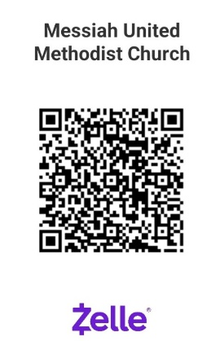

PayPal

THIS WEEK – June 21, 2026
Greeter – Tracie Chesworth
Ushers – Tracie Chesworth, David Abeshaheen
Offering Counters – Phyllis Abeshaheen, Beverley Parrish
Hospitality – Barbara Kesner
Scripture Reader – Nehemiah 18:1-12 – Tracie Chesworth
Children’s Church – Kristal Young, Lynne Shuler
Nursery – Sophie Doss, Florence Angeles

NEXT WEEK – June 28, 2026
Greeter – Florence & Robert Angeles
Ushers – Florence & Robert Angeles
Offering Counters – Deb Graham, Pat Wright
Hospitality – Terry Lumber
Scripture Reader – Jeremiah 1:1-10 – Debbie White
Children’s Church – Barbara Kesner, Anita Young
Nursery – Sophie Doss, Deb Graham

Upcoming Church Events
June 23 at 9:30-11:00 AM – Summer Playgroup begins thru August 25th – Pack up and head over to Messiah on Tuesday mornings this summer for free play time on the playground, Storytime and a cold treat. Child/parent led play, meet new friends. All ages are welcome, bring a friend! We are adding some special surprise activities planned throughout the summer. If you’d like to donate an item to amp up the fun, please take a sticky note from the board in the narthex or scan the QR code to shop our Amazon Wish List.
June 28 at 9:30 AM – Hatching Faith Fellowship – start your Sunday off with all ages engagement in worship together. Meet in the Resource room.
July 13 at 7:00 PM – Book Club - After taking June off, we’ll be meeting to discuss” The Book of Joy: Lasting Happiness in a Changing World” by Nobel Laureats the Archibishop Desmund Tutu and the Dalai Lama.
Messiah Preschool 2026-2027 Registration– Accepting applications for all families. Get your application in person or online at messiahchurchpreschool.org
Summer Camp at Occohannock on the Bay – Register at www.ootbay.org Scholarships available from Messiah Mission Women! Contact Deb Graham or the church office. Registration closes 2 weeks ahead of each session start date. More information available in the green binder in the narthex and on the camp website. Don’t miss out!

NOTES
(Prayer requests, updates or questions for Pastor Lauren? Add your name and place bulletin in the offering basket if you’d like to share with Pastor Lauren or the church staff.)

