Order of Worship
Messiah United Methodist Church
Sunday, April 26, 2026
Both/And – Sacred and Secular

Welcome, Announcements, Opening Prayer
Call To Worship

Open Up the Heavens
Jesus Son of Man

Baptism and New Membership

Dismissal to Children’s Church
Prayer For Illumination

Scripture Lesson
Acts 10:9-16

Sermon
Prayers of the People

Offertory
Take My Life and Let It Be (UMH #399)
Doxology

Offering Prayer

The Way

Benediction

Looking to make an online offering?
Scan this QR code

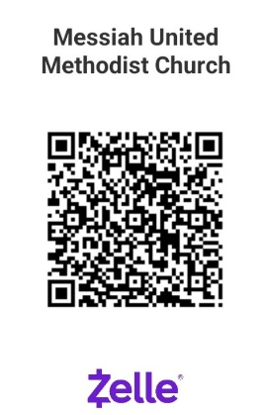

PayPal

THIS WEEK – April 26, 2026
Greeter – Deb Graham
Ushers – Florence & Robert Angeles
Offering Counters – Donna Kumjian, Clyde Stephens
Hospitality – Beverley Parrish
Scripture Reader –Acts 10:9-16 – Donna Kumjian
Children’s Church – Alicia Tracey, Lynne Shuler
Nursery – Sophie Doss, Mary Kumjian

NEXT WEEK – May 3, 2026
Greeter – Annette Kellum
Ushers – Annette Kellum, Terry Lumber
Offering Counters – Phyllis Abeshaheen, Deb Graham
Hospitality – Terry Lumber
Scripture Reader –1 Timothy 1:12-17 – Glenn McGrath
Communion Servers – Phyllis & David Abeshaheen, Bev Parrish
Children’s Church – Barbara Kesner, Anita Young
Nursery – Sophie Doss, Florence Angeles

Upcoming Church Events
May 2 at 5-7PM – BBQ Dinner & Bake Sale – fundraiser hosted by the Messiah Mission Women to support local missions. Don’t forget to pick-up your pre-ordered dinners!
May 3 at 5-7:30pm – Youth Worship Night at Deep Creek UMC – pizza, games and worship time. RSVP by May 3rd 12pm to youth@deepcreekumc.org
May 11 at 7:00 PM – Book Club “Nevertheless, She Preached” by Margaret T. Kutz – Read and discuss with us the Story of the two earliest Methodist Clergywomen of Virginia
June 7 – Graduates Recognition - Picnic luncheon for all provided by the MMW. If you or someone in your family is graduating from high school, college, grad school or a trade school this year, please let Donna Kumjian (dkumjian@aol.com) or the church office know.
Messiah Preschool 2026-2027 Registration– Accepting applications for all families. Get your application in person or online at messiahchurchpreschool.org
Summer Camp at Occohannock on the Bay – Register at www.ootbay.org Scholarships available from Messiah Mission Women! Contact Deb Graham or the church office

NOTES
(Prayer requests, updates or questions for Pastor Lauren? Add your name and place bulletin in the offering basket if you’d like to share with Pastor Lauren or the church staff.)

