Order of Worship
Messiah United Methodist Church
Sunday, March 22, 2026
Journey to the Cross: Honor and Service

Welcome, Announcements, Opening Prayer
Call To Worship

Blessed Be Your Name
Your Grace Finds Me

Dismissal to Children’s Church

Prayer For Illumination

Scripture Lesson
Mark 10:35-45

Sermon
Prayers of the People

Offertory
The Old Rugged Cross (UMH #504)
Doxology

Offering Prayer

Reckless Love

Benediction

Looking to make an online offering?
Scan this QR code
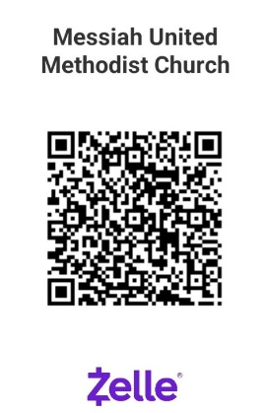
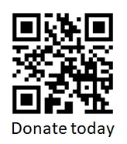
PayPal

THIS WEEK – March 22, 2026
Greeter – Florence & Robert Angeles
Ushers – Susan Stout, Beth Yelverton
Offering Counters – Susan Stout, Don Robison
Hospitality – Jennifer Ferguson
Scripture Reader –Mark 10:35-45 – Terry Lumber
Children’s Church – Christina Everhart, Melissa Edmunds
Nursery – Sophie Doss, Alicia Tracey
Acolyte – Landon Holcombe

NEXT WEEK – March 29, 2026 – Palm Sunday
Greeter – Gionis family
Ushers – Donna Kumjian, Terry Lumber
Offering Counters – Phyllis Abehsaheen, Scott Tracey
Hospitality – Barbara Kesner
Scripture Reader –Mark 11:1-11 – David Abeshaheen
Children’s Church – Donna Collier, Alicia Tracey
Nursery – Sophie Doss, Mary Kumjian

Upcoming Church Events
Holy Week Schedule:
March 29 – Palm Sunday Potluck & Easter Egg Hunt – Let’s gather as a family for fellowship and fun as we remember and celebrate Jesus’ entry into Jerusalem.
April 2 at 7:00PM - Maundy Thursday service at Oak Grove UMC
April 3 at 7:00PM – Good Friday service and Cantata at Great Bridge UMC. Contact Pastor Lauren for cantata details
April 5 at 6:30AM – Sunrise Easter service at the Great bridge Battlefield and Waterways History Foundation
April 5 at 11:00AM – Easter Worship service at Messiah UMC

Messiah Preschool 2026-2027 Registration– Accepting applications for all families. Get your application in person or online at messiahchurchpreschool.org
Mondays @ 1:30PM – Seniors Seated Exercise Class – strengthen your body and spirit with a guided gentle movement class. Classes cost $5.00 per class. Contact Delphine dam2210@aol.com to sign up.
Summer Camp at Occohannock on the Bay – Register at www.ootbay.org Scholarships available from Messiah Mission Women! Contact Deb Graham or the church office

NOTES
(Prayer requests, updates or questions for Pastor Lauren? Add your name and place bulletin in the offering basket if you’d like to share with Pastor Lauren or the church staff.)

